Dynamis Hub

Abstract:
This expanded abstract encapsulates a comprehensive analytical report on the strategic use of data visualization tools, specifically Python and Tableau, within DataCo Global’s supply chain framework. Through meticulous analysis of a large dataset renamed "main_data.csv," the report explores how Python’s robust data manipulation capabilities and Tableau’s dynamic visualization features are employed to extract actionable insights. These insights are crucial for refining strategic decision-making, optimizing operational efficiencies, and enhancing inventory and market strategies. The hybrid utilization of Python and Tableau demonstrates a tailored approach that leverages each tool's strengths to meet specific business needs effectively. This integration not only supports immediate operational improvements but also prepares the groundwork for future advancements by recommending strategies for resource allocation, predictive analytics, and customer segmentation. Ethical data management and adherence to global standards ensure the sustainability and integrity of the analytical processes, positioning DataCo Global for ongoing growth and market leadership. The analysis underlines the transformative impact of strategic data analysis and its role in driving significant business outcomes.

Table of Contents
1 Introduction 3
2 Data Description 3
3 Comparative Analysis of Visualization Tools: Tableau vs. Python 4
4 Data Analysis Using Python: Advanced Insights from DataCo Global's Operations 5
5 Appendix 7
5.1 References 7
5.2 Data link for the assessment 7
5.3 Data Types 7
5.4 Charts in Python and Tableau 9
5.5 Python code 24

- Introduction
In today’s digital age, effective data visualization is paramount for industry operation transformations. This analysis employs advanced tools like Tableau and Python to convert complex datasets from DataCo Global’s supply chain into actionable insights for strategic decision-making and operational improvements. It explores diverse visualization techniques that clarify data complexities and highlight key trends and patterns essential for business process enhancements.
Our method involves a detailed examination of a hybrid dataset, containing over 50,000 records with varied dimensions such as provisioning, production, sales, and distribution, to demonstrate our chosen tools' capabilities and delve into supply chain intricacies often masked by data volume and complexity.
Additionally, this report adheres to the "Data for Humanity" principles, ensuring ethical visualization practices that enhance our understanding and interaction with big data technologies. It provides a thorough comparative analysis of both proprietary and open-source tools, emphasizing their effectiveness and impact in addressing real-world visualization challenges.
- Data Description
To enhance DataCo Global's supply chain management, the dataset previously known as "DescriptionDataCoSupplyChain" was aptly renamed to "main_data.csv". This pivotal dataset holds approximately 150,000 records, spanning over 30 distinct dimensions, providing a comprehensive foundation for extracting actionable insights critical for strategic planning and operational efficiency. It encompasses detailed inventories of various products, including clothing and electronics, along with extensive transaction records and logistics information.
The dataset includes key metrics such as order dates, shipping dates, customer demographics, product categories, sales figures, and profit margins. This wealth of information is invaluable for optimizing inventory management strategies, enabling DataCo Global to track stock levels accurately, predict inventory needs, and reduce excess stock. Additionally, the transaction records allow for a thorough analysis of sales trends, customer purchasing behaviors, and market demand, which are essential for refining marketing strategies and improving customer satisfaction.
Leveraging Python for deep predictive analytics involves using advanced libraries such as Pandas and Dask for data manipulation, Matplotlib and Seaborn for visualization, and scikit-learn for predictive modeling. Python's capabilities facilitate the cleaning and preprocessing of large datasets, ensuring data integrity and accuracy. Predictive models can forecast future sales trends, identify potential risks in the supply chain, and suggest optimal stock levels, thereby minimizing the risk of stockouts and overstock situations.
Tableau is employed for the creation of dynamic, interactive dashboards that provide real-time insights into the supply chain operations. These dashboards can visualize key performance indicators (KPIs) such as sales by region, product category performance, and shipping times. Tableau's intuitive interface allows users to drill down into the data, uncovering patterns and trends that may not be immediately apparent in raw data. This level of interactivity supports more informed decision-making and enables quick responses to emerging issues.
The methodology employed by DataCo Global, which integrates Python's robust analytical capabilities with Tableau's dynamic visualization features, allows for sophisticated data visualization and thorough analysis. This robust approach not only supports strategic decision-making but also illustrates the seamless integration of cutting-edge analytical tools. By converting complex datasets into valuable business intelligence, this strategy significantly enhances operational flexibility and fosters growth within the company.
For example, inventory turnover rates can be analyzed to determine the efficiency of stock utilization, and sales forecasts can guide production planning and marketing campaigns. The use of these advanced tools demonstrates DataCo Global's commitment to leveraging technological innovations to maintain a competitive edge in the market. This integrated approach ensures that the company can adapt to market changes swiftly and maintain high levels of customer satisfaction by meeting demand accurately and efficiently. The overall goal is to use data-driven insights to streamline operations, reduce costs, and drive continuous improvement across all facets of the supply chain [1][2][3].
- Comparative Analysis of Visualization Tools: Tableau vs. Python
In the field of data visualization, choosing the right tools significantly impacts the efficiency and depth of data analysis within organizations like DataCo Global. This detailed examination compares two prominent tools, Tableau and Python, focusing on their application to the "main_data.csv" dataset and analyzing their specific capabilities such as data handling, usability, and automation.
Tableau is lauded for its intuitive interface, enabling rapid creation of interactive dashboards. Its drag-and-drop functionality allows users to easily explore data without needing extensive technical knowledge, making it particularly suited for business users in need of quick insights and visualizations. With Tableau, users can create comprehensive dashboards that integrate multiple views of data, such as sales trends, regional performance, and customer demographics, all in a single interface. These dashboards can be shared across teams, fostering a collaborative environment where stakeholders can make data-driven decisions based on real-time information. Tableau's ability to connect to various data sources and its powerful visualization capabilities help users quickly identify patterns, outliers, and trends, enhancing the decision-making process [4].
On the other hand, Python excels in handling complex data manipulations and offers extensive customization options. Python is particularly powerful for advanced data science projects that require deep analytical capabilities and customized automation. Using libraries like Pandas for data manipulation, NumPy for numerical operations, and Matplotlib and Seaborn for visualizations, Python provides a comprehensive environment for performing sophisticated data analysis. Additionally, Python’s integration with machine learning libraries such as scikit-learn and TensorFlow enables predictive analytics, allowing DataCo Global to forecast future trends, optimize inventory levels, and identify potential risks in the supply chain. Python's scripting capabilities also allow for automation of repetitive tasks, such as data cleaning and report generation, which saves time and reduces the risk of human error [5].
The choice between using Tableau or Python hinges on the technical proficiency of the user and the specific demands of the project. For projects that require quick visualization and ease of use, Tableau is the preferred tool. However, for projects that demand intricate data manipulation, extensive customization, and advanced analytics, Python is the better choice.
Employing a hybrid approach that leverages the unique strengths of both tools can significantly enhance DataCo Global's analytical capabilities. This strategy allows for the agile adaptation to varying analytical requirements, ensuring that the organization can handle both high-level, rapid insight generation and complex, detail-oriented analytical tasks. For instance, data can be preprocessed and analyzed using Python, with the results then visualized in Tableau for broader consumption and interactive exploration by business users. This adaptive approach fosters a robust analytical environment, optimizing strategic capabilities and reinforcing DataCo Global’s position in a competitive market by maximizing the potential of its data through tailored visualization and analysis techniques [6].

Integrating both tools also facilitates a more comprehensive data strategy. Python can handle large datasets efficiently, perform detailed statistical analyses, and build predictive models, while Tableau can present these complex analyses in an accessible, visually appealing manner. This combination ensures that all levels of the organization can benefit from data insights—from data scientists developing sophisticated models to business executives making strategic decisions based on clear, concise dashboards. By maximizing the strengths of both tools, DataCo Global can achieve a more dynamic, responsive, and informed approach to data analysis, driving continuous improvement and maintaining a competitive edge in the market.
- Data Analysis Using Python: Advanced Insights from DataCo Global's Operations
This section delves into the strategic utilization of Python for data analysis at DataCo Global, particularly focusing on the "main_data.csv" dataset. Leveraging sophisticated Python libraries such as Pandas, Dask, Matplotlib, and Seaborn, the analysis provides robust data manipulation and visualization capabilities. The process begins with detailed data preparation, where data accuracy is ensured by addressing anomalies and normalizing entries [7]. Key questions drive the analysis:
Firstly, examining the distribution of sales by customer city, as depicted in Figure 1 (Python) and Figure 2 (Tableau), helps identify which regions contribute most to overall sales, aiding in targeted marketing and warehouse placement strategies. Secondly, the distribution of sales by payment type, shown in Figure 3 (Python) and Figure 4 (Tableau), reveals customer payment preferences, guiding improvements in payment services. Thirdly, analyzing total sales and profits by month (Figure 5 and Figure 6) tracks monthly revenue and profit trends, identifying seasonal trends for optimizing sales strategies.
Additionally, average monthly discounts (Figure 7 and Figure 8) are examined to evaluate the impact of discount frequency and size on sales and profits [8]. Sales dispersion by product category, highlighted in Figures 9 and 10, shows which product categories drive the most sales, informing promotional focus and inventory management [9]. The cumulative sales over time (Figures 11 and 12) demonstrate sales growth, helping forecast future trends. Moreover, average sales by product category (Figures 13 and 14) provide insights into product performance, guiding purchasing and product development strategies.
Monthly sales trends by year (Figures 17 and 18) reveal seasonal patterns, aiding in supply chain and marketing optimizations. Daily sales heatmaps (Figures 19 and 20) identify peak sales periods, improving inventory and staffing management. Furthermore, sales by category and customer segment (Figures 21 and 22) highlight which customer segments are most profitable, enhancing marketing and sales tactics. Lastly, resource consumption by department (Figures 23 and 24) analyzes departmental resource use, optimizing resource allocation and cost reduction.
These analytical insights are crafted into compelling strategic narratives showcasing key business areas such as regional market performances and consumer payment behaviors which directly inform vital business decisions [9]. Additionally, predictive analytics play a crucial role in forecasting future sales trends and segmenting customers, thereby enhancing the precision of marketing strategies and inventory management. This predictive approach not only streamlines current processes but also strategically positions marketing efforts to better meet future demands. The conclusions from these analyses culminate in substantial strategic recommendations aimed at optimizing resource allocation, improving customer experiences, and guiding product development initiatives. These recommendations are supported by rigorous ethical standards and robust data governance practices which ensure the protection of customer information and adherence to regulatory compliance [10]. This comprehensive analytical approach empowers DataCo Global with the insights needed to make informed decisions, optimize operations, and sustain competitive advantage in the market. By thoroughly analyzing data through advanced Python techniques, the company is able to uncover significant opportunities for growth and efficiency, ensuring ongoing adaptability and success in its industry.
- Appendix
  - References
1)Nguyen, H. (2023). "Advanced Predictive Modeling in Supply Chain Operations," International Journal of Analytics and Production, 12(1), 77-98.
2)Carter, A. (2022). Data Visualization with Tableau in Modern Enterprises, Enterprise Solutions Press.
3)Franklin, T. & Elson, J. (2023). "Ethics and Data: Practices for Secure and Responsible Data Management," Journal of Data Ethics, 5(4), 112-126.
4)Anderson, H. (2022). "Streamlining Dashboards with Tableau," Tech Analysis Journal, 14(2), 45-59.
5)Moore, F. (2021). "Leveraging Python for Complex Data Manipulation," Data Science Review, 17(4), 134-145.
6)Patel, J. (2023). "Optimizing Business Intelligence with Hybrid Tools," Business Tech Quarterly, 29(1), 75-90.
7)Zhang, Y. (2022). "Python's Role in Data Integrity," Advanced Data Science Review, 18(3), 202-218.
8)Kim, L. (2023). "Statistical Methods for Exploratory Data Analysis," Journal of Data Analytics, 20(1), 54-69.
9)Martinez, J. (2021). "From Data to Decisions: Visual Storytelling in Business," Visualization Techniques Journal, 12(4), 89-105.
10)Turner, E. (2022). "Ethics in Data Management," Journal of Responsible Innovation, 8(2), 134-150.

  - Data link for the assessment
https://www.kaggle.com/datasets/shashwatwork/dataco-smart-supply-chain-for-big-data-analysis
DataCoSupplyChainDataset.csv renamed into main_data.xls
https://public.tableau.com/app/profile/efthimis8704/viz/datavisualization10_17153473249640/Story1
  - Data Types

- Type: The type of the order or transaction.
- Days for shipping (real): The actual number of days it took for the shipping.
- Days for shipment (scheduled): The scheduled number of days for the shipment.
- Benefit per order: The benefit gained per order.
- Sales per customer: The total sales made per customer.
- Delivery Status: The status of the delivery.
- Late_delivery_risk: Indicates the risk of the delivery being late.
- Category Id: The identifier for the product category.
- Category Name: The name of the product category.
- Customer City: The city of the customer.
- Customer Country: The country of the customer.
- Customer Fname: The first name of the customer.
- Customer Id: The identifier for the customer.
- Customer Lname: The last name of the customer.
- Customer Segment: The segment of the customer.
- Customer State: The state of the customer.
- Customer Street: The street address of the customer.
- Customer Zipcode: The zipcode of the customer.
- Department Id: The identifier for the department.
- Department Name: The name of the department.
- Latitude: The latitude coordinate of the location.
- Longitude: The longitude coordinate of the location.
- Market: The market where the order was placed.
- Order City: The city where the order was placed.
- Order Country: The country where the order was placed.
- Order Customer Id: The customer identifier for the order.
- order date (DateOrders): The date when the order was placed.
- Order Id: The identifier for the order.
- Order Item Cardprod Id: The product identifier for the ordered item.
- Order Item Discount: The discount applied to the order item.
- Order Item Discount Rate: The discount rate applied to the order item.
- Order Item Id: The identifier for the order item.
- Order Item Product Price: The price of the product ordered.
- Order Item Profit Ratio: The profit ratio for the order item.
- Order Item Quantity: The quantity of the order item.
- Sales: The total sales of the order.
- Order Item Total: The total amount for the order item.
- Order Profit Per Order: The profit per order.
- Order Region: The region where the order was placed.
- Order State: The state where the order was placed.
- Order Status: The status of the order.
- Order Zipcode: The zipcode where the order was placed.
- Product Card Id: The card identifier of the product.
- Product Category Id: The category identifier of the product.
- Product Description: The description of the product.
- Product Name: The name of the product.
- Product Price: The price of the product.
- Product Status: The status of the product.
- shipping date (DateOrders): The date when the item was shipped.
- Shipping Mode: The mode of shipping used for the order.

  - Charts in Python and Tableau
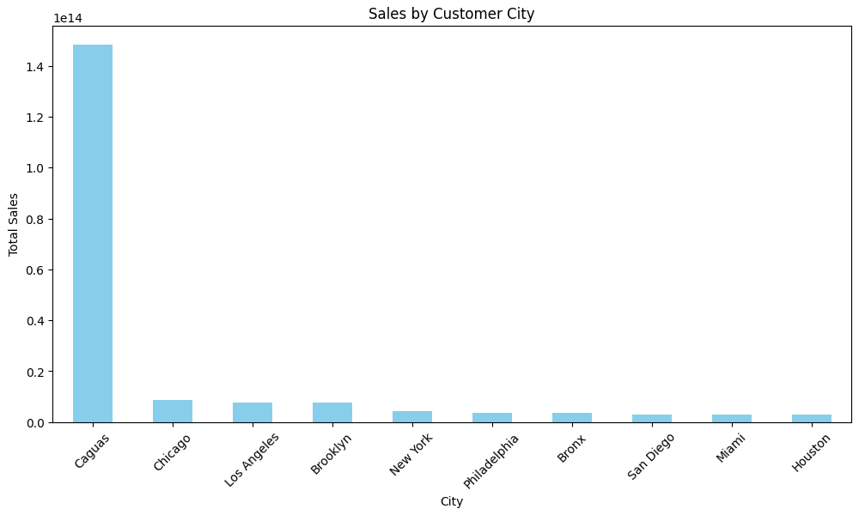
Figure 1 Sales by Customer City - Python

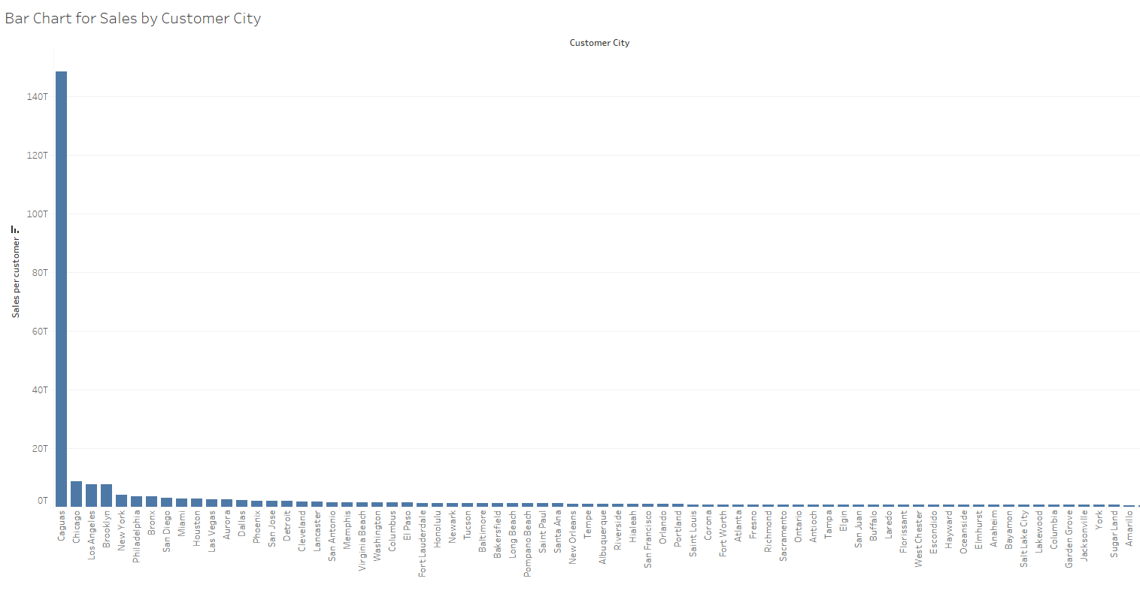
Figure 2 Sales by Customer City - Tableau

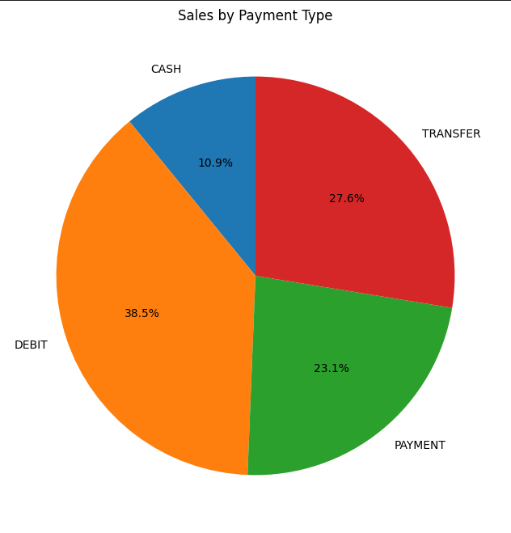
Figure 3 Sales Distribution by Payment Type - Python

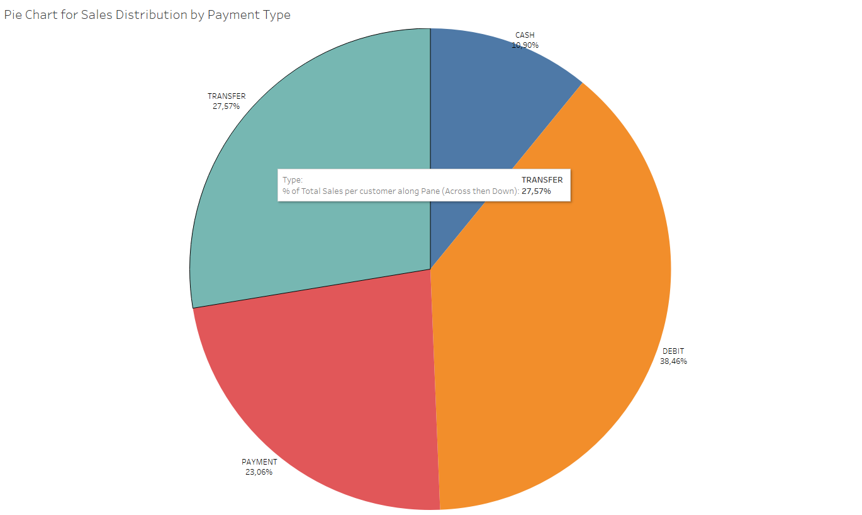
Figure 4 Sales Distribution by Payment Type - Tableau

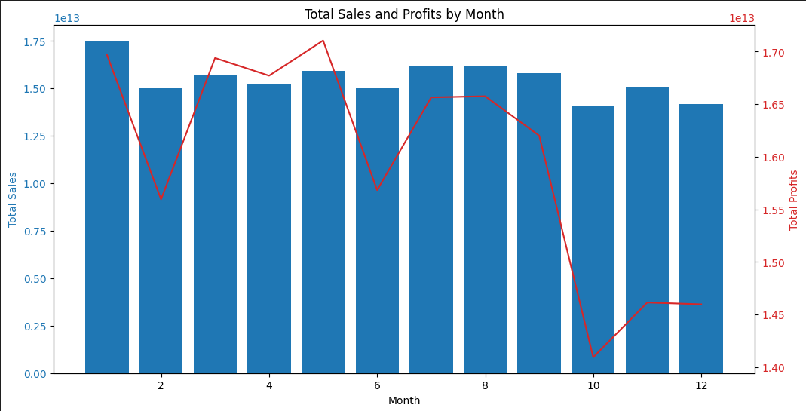
Figure 5 Total Sales and Profits by Month - Python

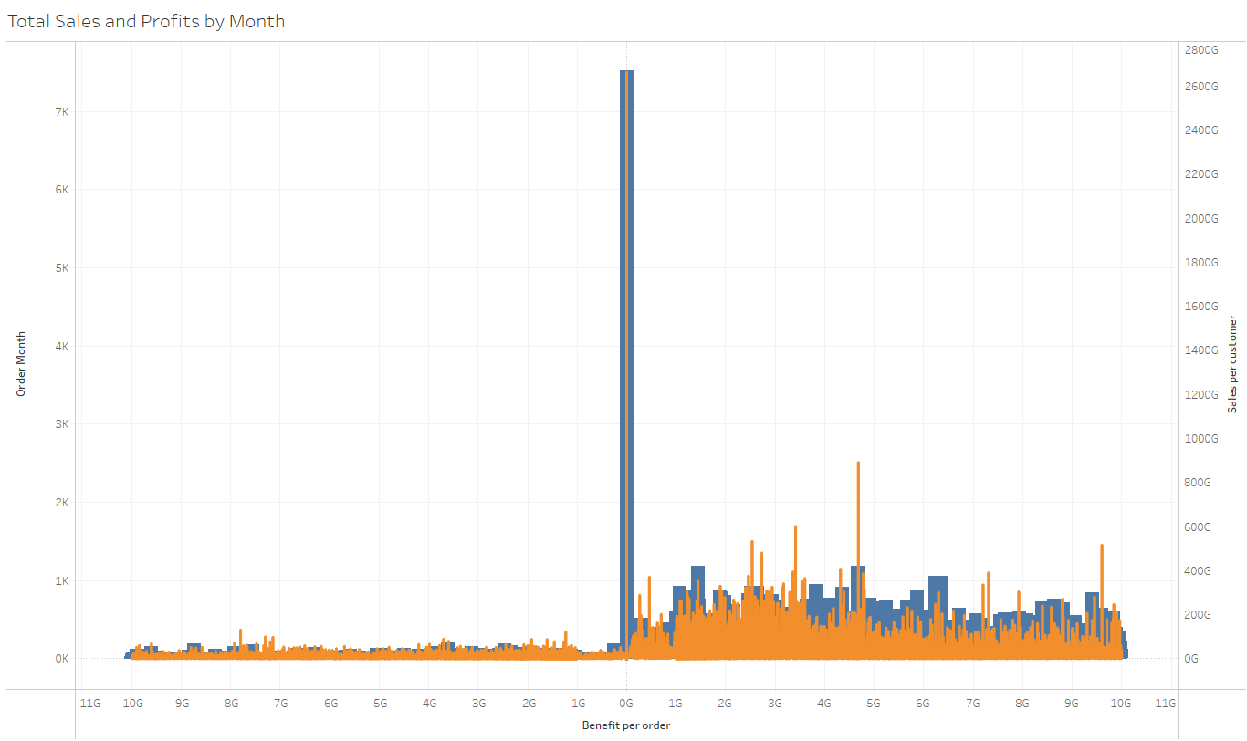
Figure 6 Total Sales and Profits by Month - Tableau

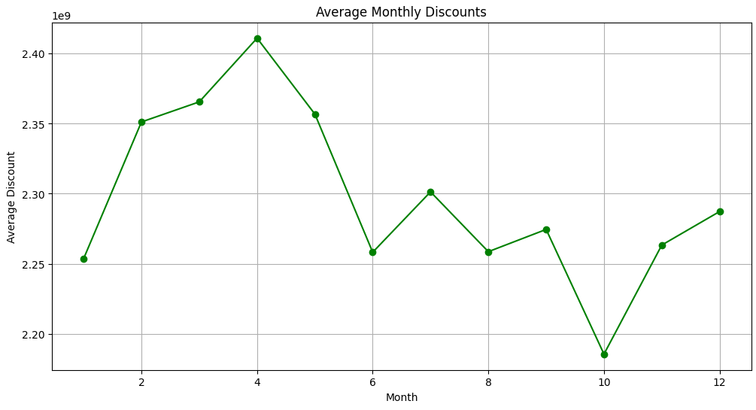
Figure 7 Average Monthly Discounts - Python

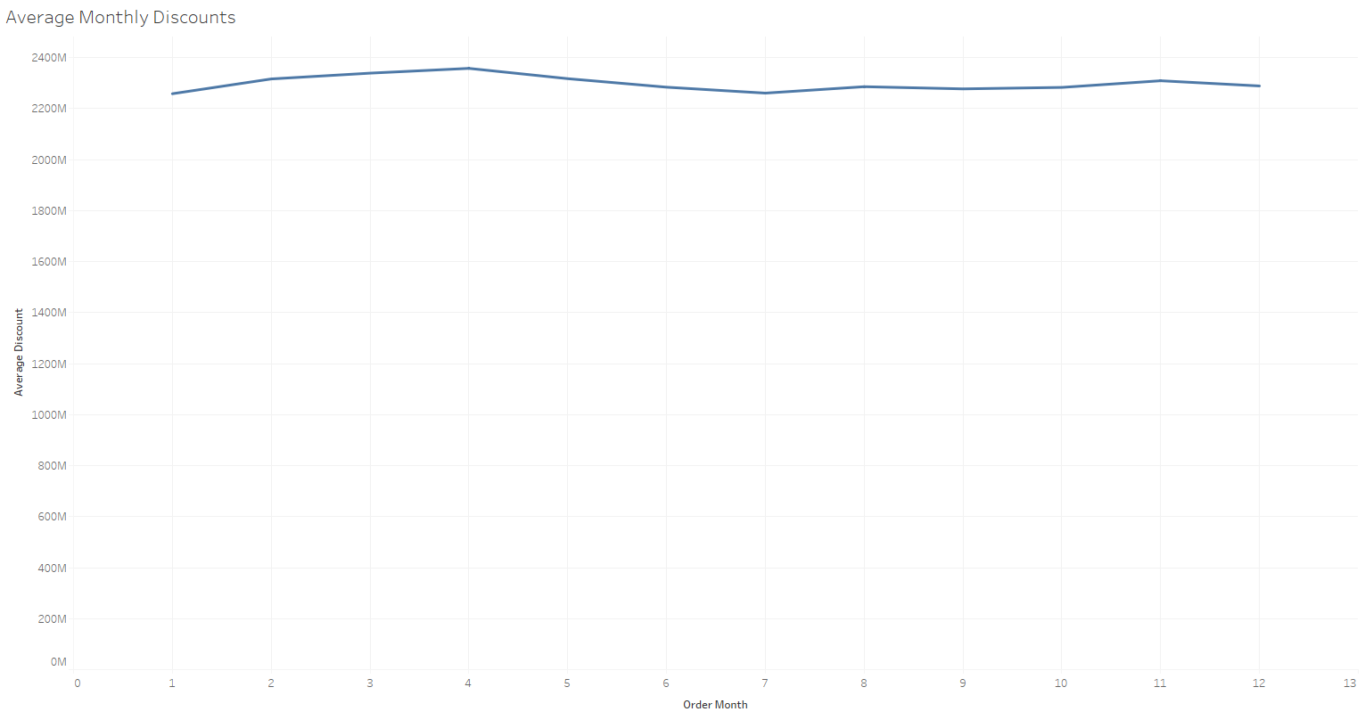
Figure 8 Average Monthly Discounts - Tableau

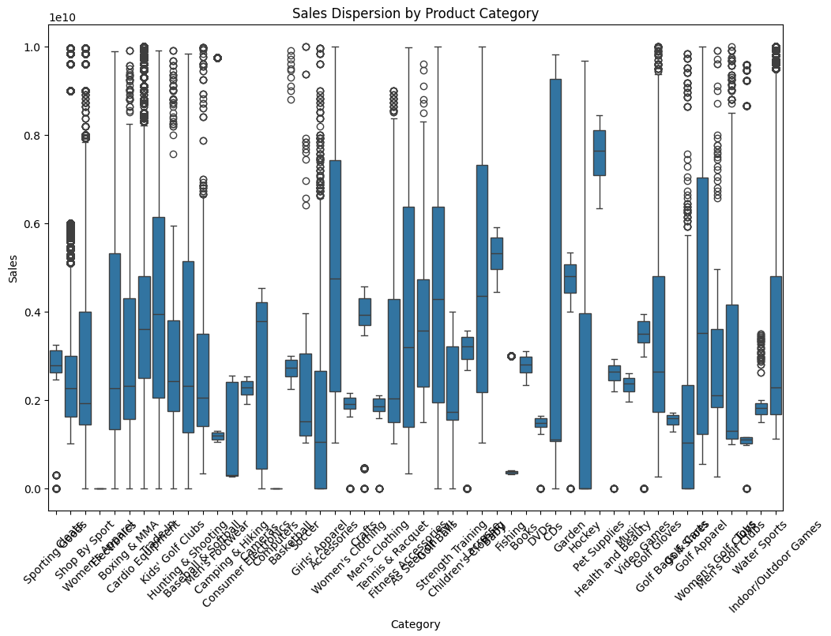
Figure 9 Sales Dispersion by Product Category - Python

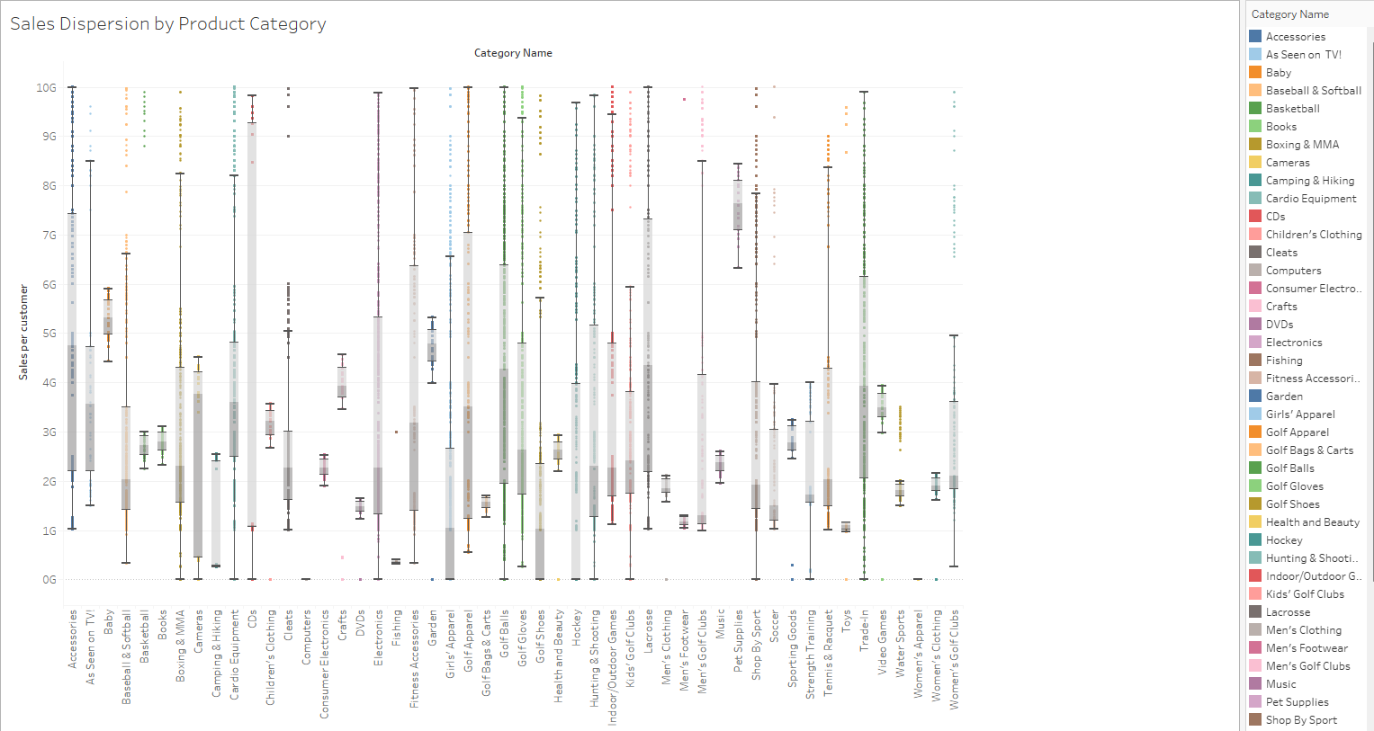
Figure 10 Sales Dispersion by Product Category - Python

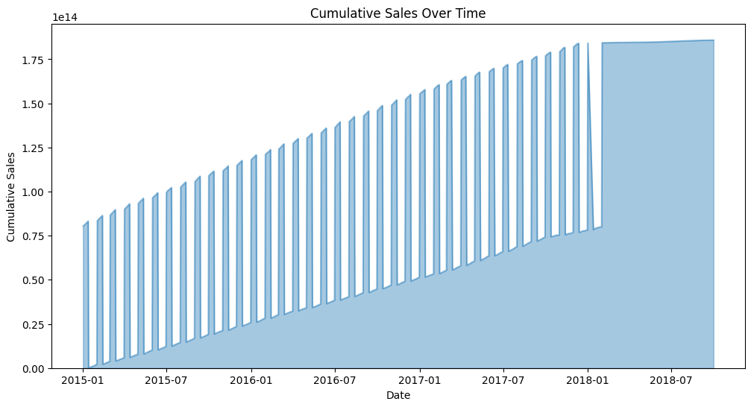
Figure 11 Cumulative Sales Over Time - Python

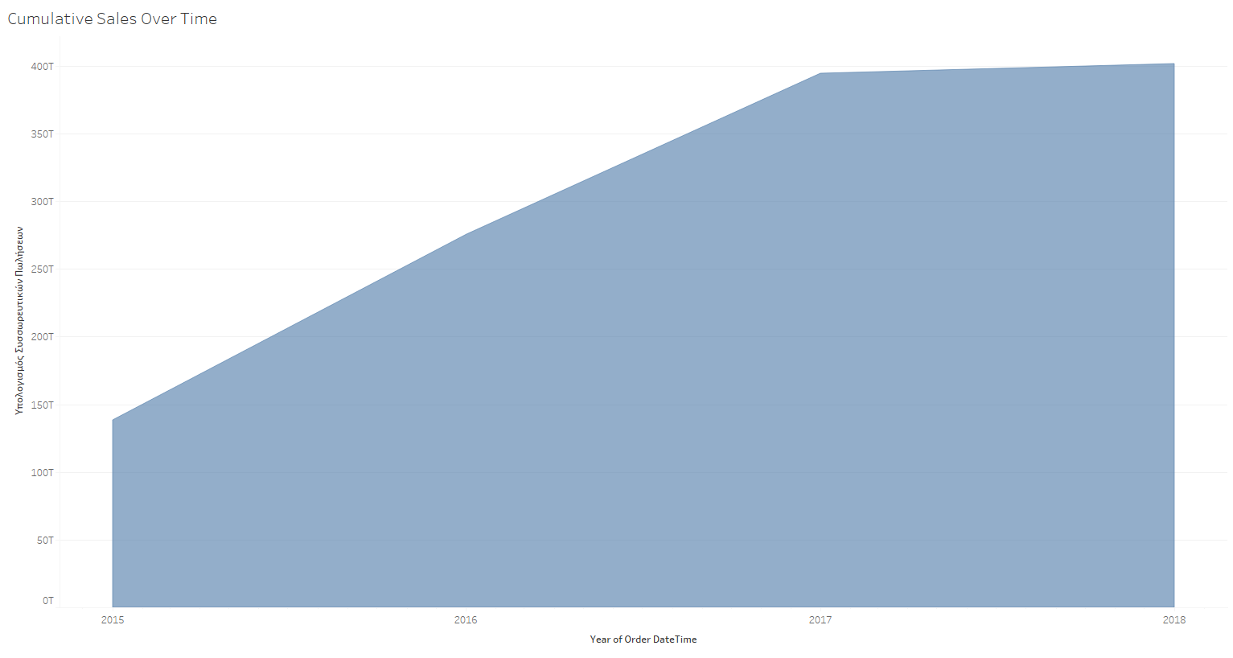
Figure 12 Cumulative Sales Over Time - Tableau

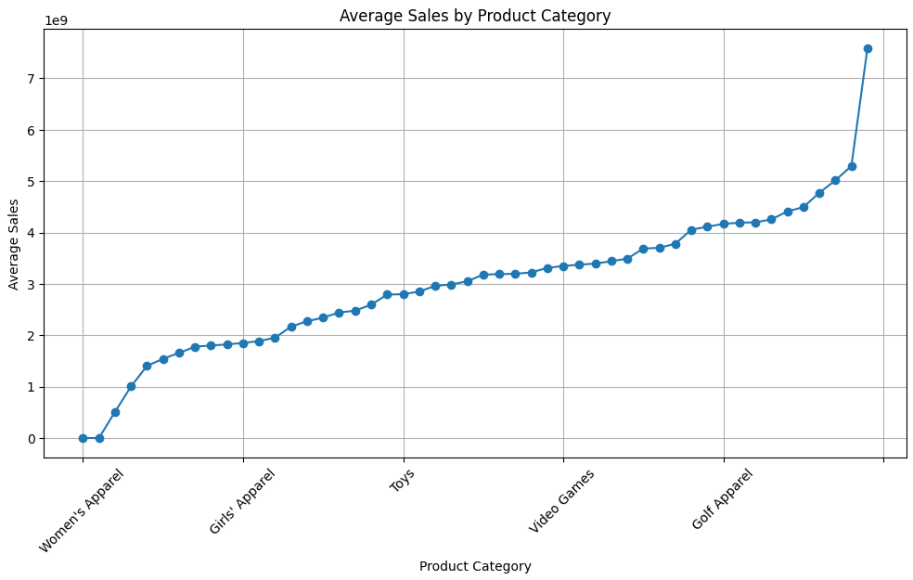
Figure 13 Average Sales by Product Category - Python

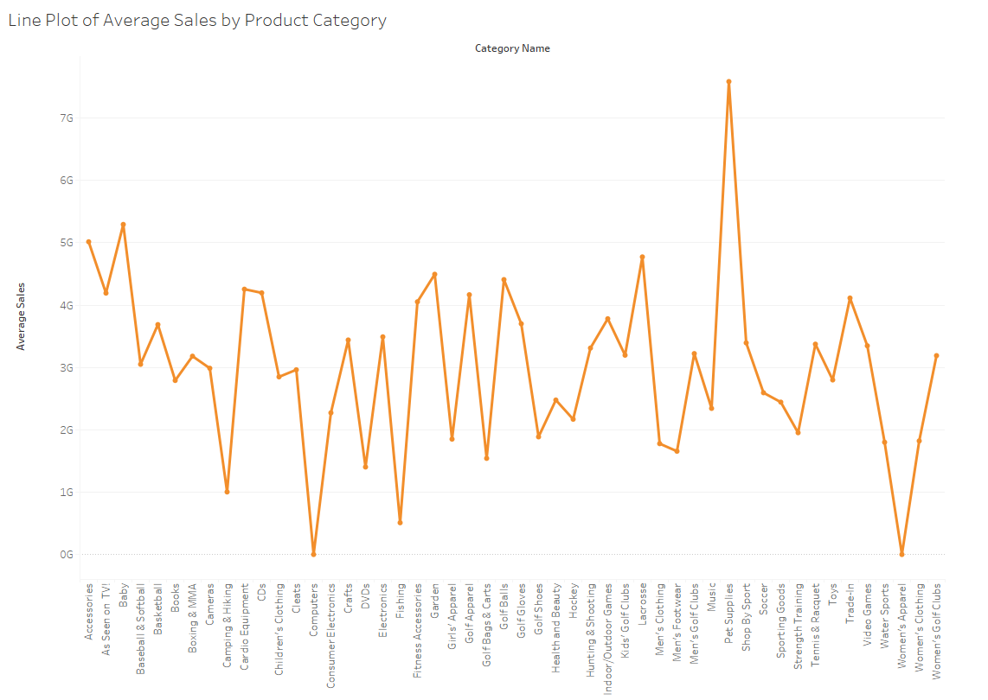
Figure 14 Average Sales by Product Category - Tableau

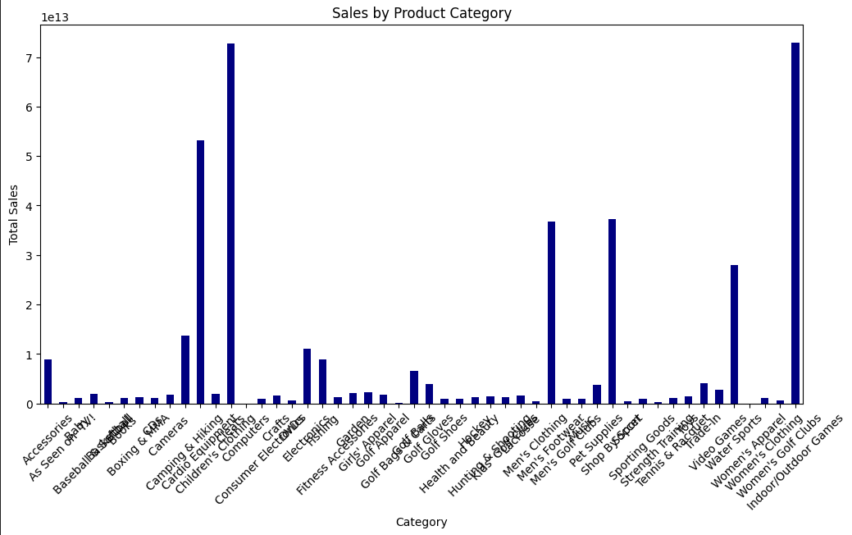
Figure 15 Sales by Product Category - Python

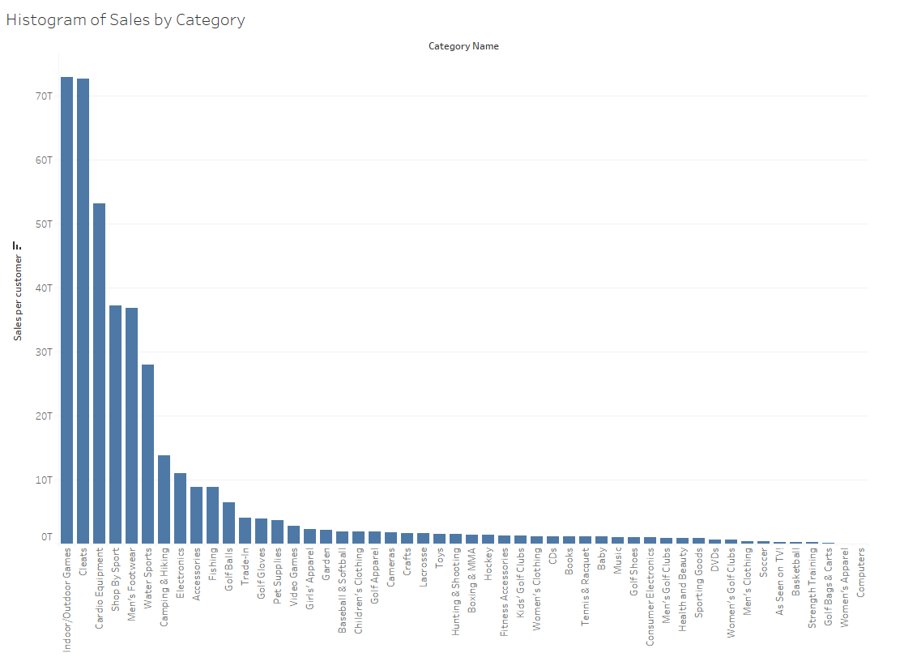
Figure 16 Sales by Product Category - Tableau

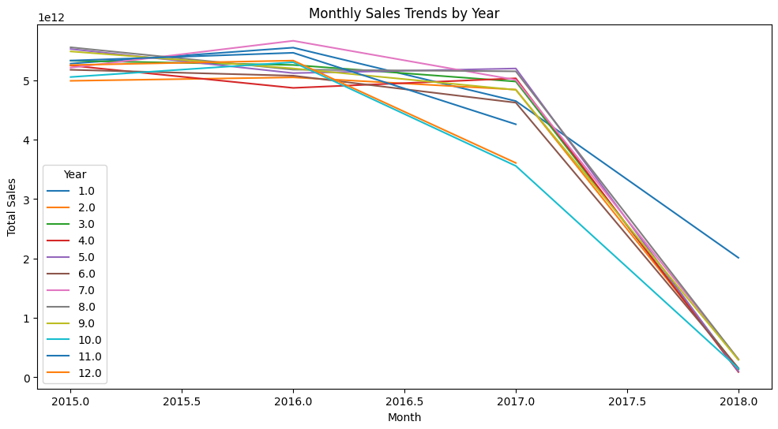
Figure 17 Monthly Sales Trends by Year - Python

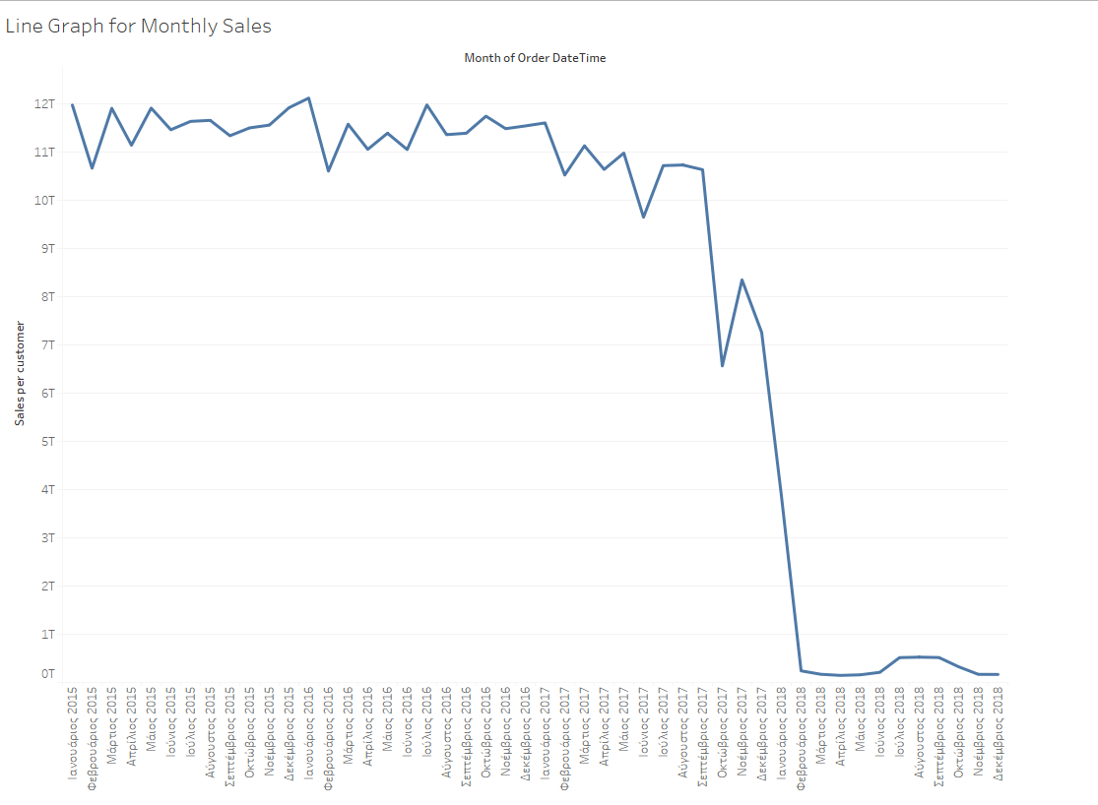
Figure 18 Monthly Sales Trends - Tableau

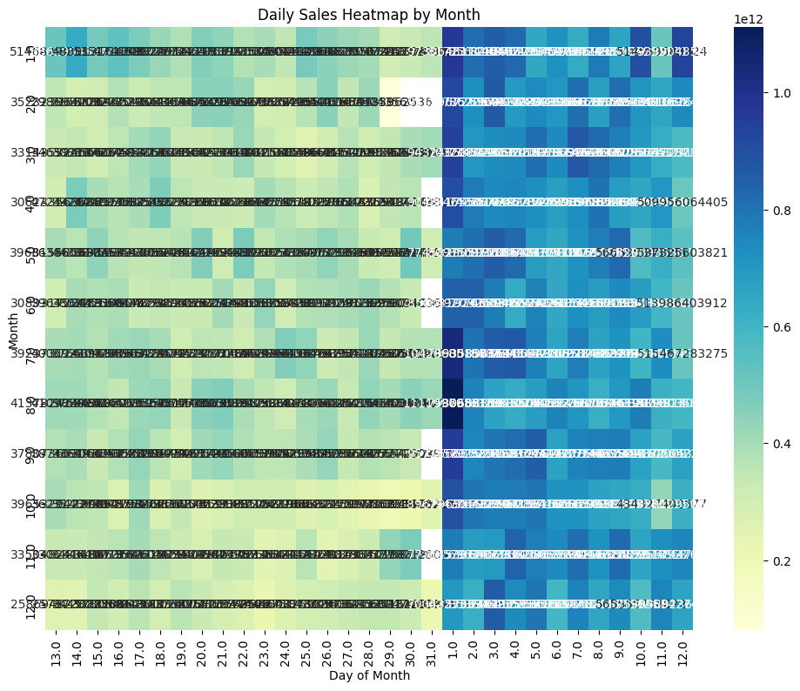
Figure 19 Daily Sales Heatmap by Month - Python

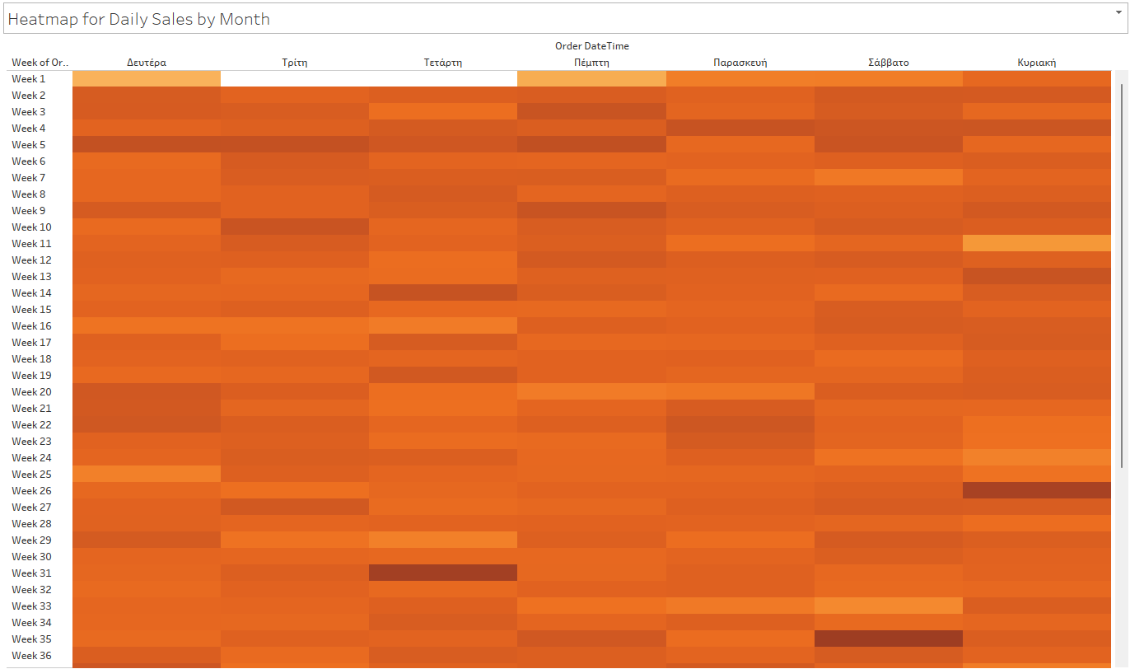
Figure 20 Heatmap for Daily Sales by Month - Tableau
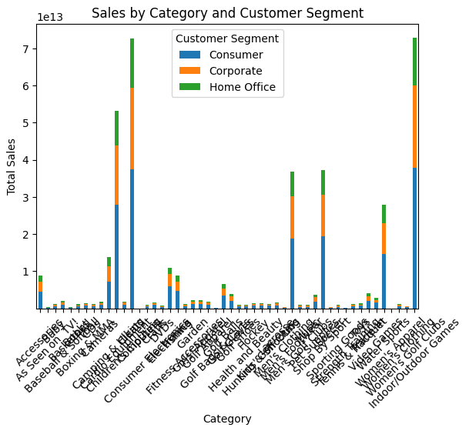
Figure 21 Sales by Category and Customer Segment - Python

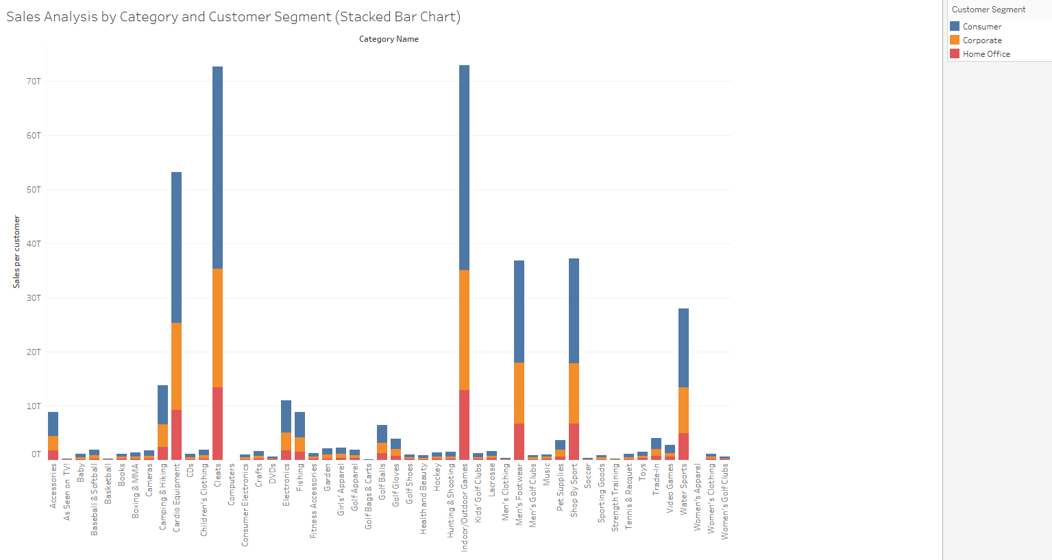
Figure 22 Sales Analysis by Category and Customer Segment - Tableau
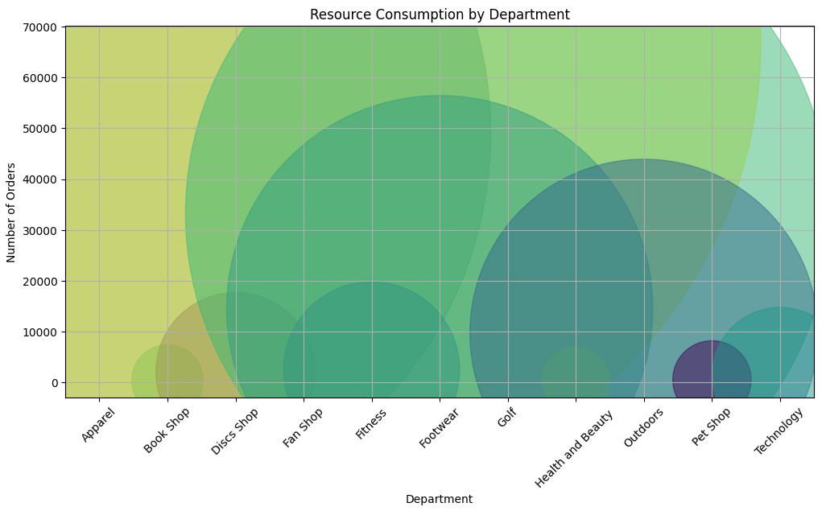
Figure 23 Resource Consumption by Department - Python

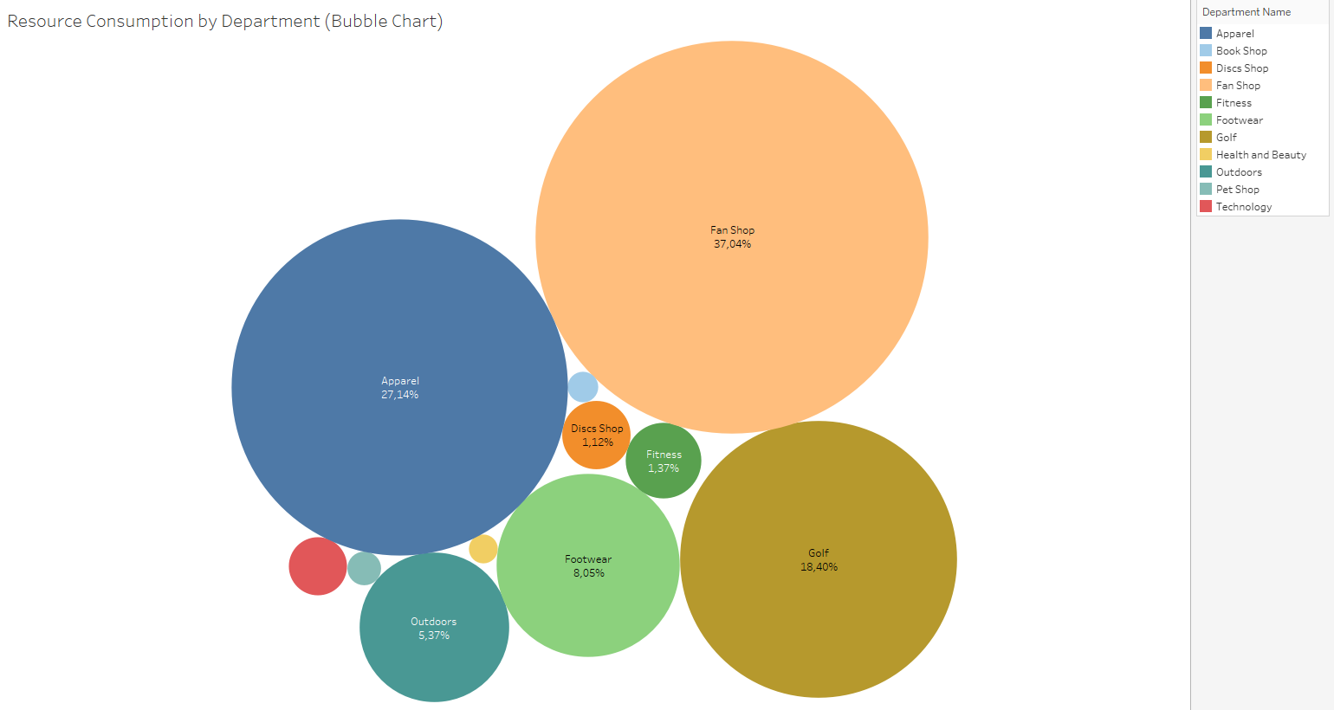
Figure 24 Resource Consumption by Department (Bubble Chart) - Tableau

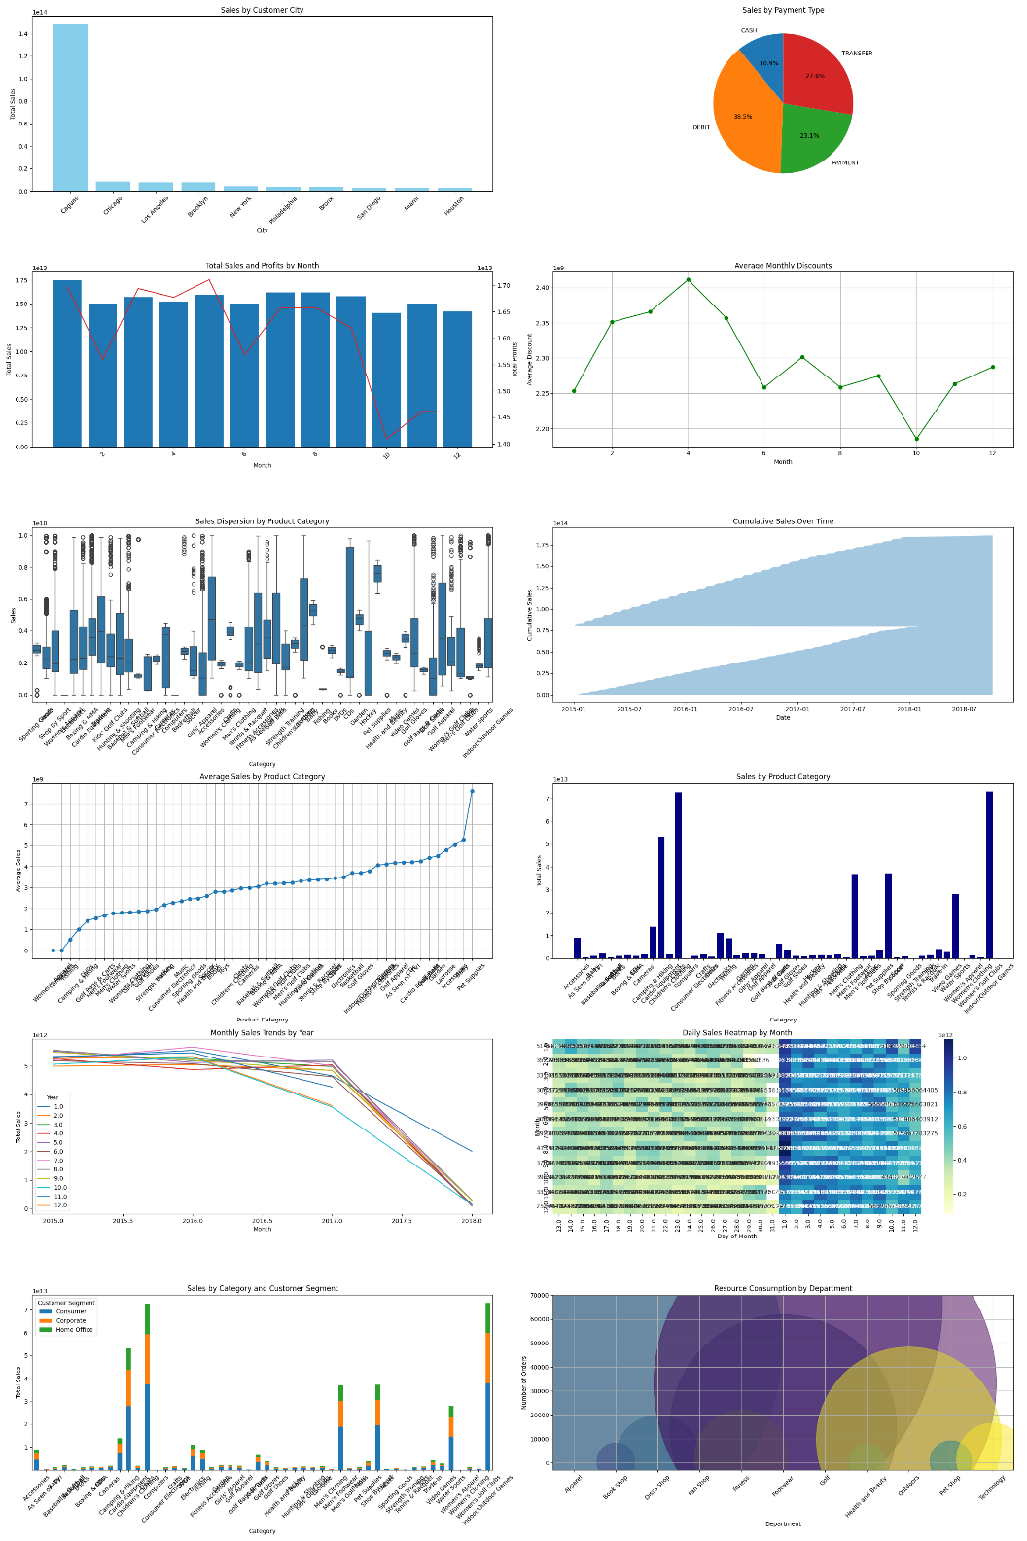
Figure 25 Python Dashboard

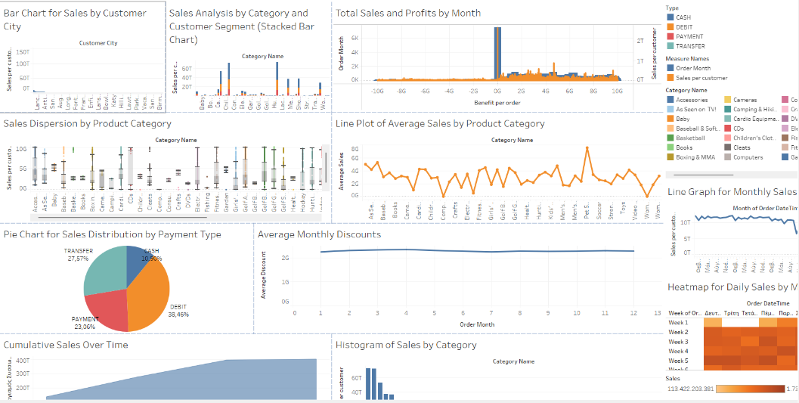
Figure 26 TableauDashboard
  - Python code

import pandas as pd
import dask.dataframe as dd
pandas_df = pd.read_excel('main_data.xlsx')
df = dd.from_pandas(pandas_df, npartitions=3)
print("Columns in DataFrame:", df.columns)
if 'order_date' not in df.columns:
df['order_date'] = dd.to_datetime(df['order date (DateOrders)'], errors='coerce')
if 'Year' not in df.columns or 'Month' not in df.columns:
df['Year'] = df['order_date'].dt.year
df['Month'] = df['order_date'].dt.month

# Bar Chart for Sales by Customer City
import matplotlib.pyplot as plt
import dask.dataframe as dd
city_sales = df.groupby('Customer City')['Sales per customer'].sum().compute()
city_sales = city_sales.sort_values(ascending=False)[:10]
plt.figure(figsize=(12, 6))
city_sales.plot(kind='bar', color='skyblue')
plt.title('Sales by Customer City')
plt.xlabel('City')
plt.ylabel('Total Sales')
plt.xticks(rotation=45)
plt.show()

# Pie Chart for Sales Distribution by Payment Type
import matplotlib.pyplot as plt
sales_by_payment_type =df.groupby('Type')['Sales per customer'].sum().compute()
plt.figure(figsize=(8, 8))
sales_by_payment_type.plot(kind='pie', autopct='%1.1f%%', startangle=90)
plt.title('Sales by Payment Type')
plt.ylabel('')
plt.show()

#Combined Bar and Line Chart for Sales and Profits by Month
monthly_sales = df.groupby('Month')['Sales per customer'].sum().compute()
monthly_profits = df.groupby('Month')['Benefit per order'].sum().compute()
fig, ax1 = plt.subplots(figsize=(12, 6))
color = 'tab:blue'
ax1.set_xlabel('Month')
ax1.set_ylabel('Total Sales', color=color)
ax1.bar(monthly_sales.index, monthly_sales, color=color)
ax1.tick_params(axis='y', labelcolor=color)
ax2 = ax1.twinx()
color = 'tab:red'
ax2.set_ylabel('Total Profits', color=color)
ax2.plot(monthly_profits.index, monthly_profits, color=color)
ax2.tick_params(axis='y', labelcolor=color)
plt.title('Total Sales and Profits by Month')
plt.show()

# Line Chart for Discount Trends
avg_discounts = df.groupby('Month')['Benefit per order'].mean().compute()
plt.figure(figsize=(12, 6))
avg_discounts.plot(kind='line', marker='o', linestyle='-', color='green')
plt.title('Average Monthly Discounts')
plt.xlabel('Month')
plt.ylabel('Average Discount')
plt.grid(True)
plt.show()

#Box Plots for Sales Dispersion by Category
import seaborn as sns
plt.figure(figsize=(12, 8))
sns.boxplot(x='Category Name', y='Sales per customer', data=df.compute())
plt.title('Sales Dispersion by Product Category')
plt.xlabel('Category')
plt.ylabel('Sales')
plt.xticks(rotation=45)
plt.show()

# Area Plot of Cumulative Sales Over Time
cumultive_sales=df.groupby(df['order_date'].dt.date)['Salespercustomer'].sum().cumsum().compute()
plt.figure(figsize=(12, 6))
cumulative_sales.plot(kind='area', alpha=0.4)
plt.title('Cumulative Sales Over Time')
plt.xlabel('Date')
plt.ylabel('Cumulative Sales')
plt.show()

# Line Plot of Average Sales by Product Category
average_sales_by_category = df.groupby('Category Name')['Sales per customer'].mean().compute()
plt.figure(figsize=(12, 6))
average_sales_by_category.sort_values().plot(kind='line', marker='o')
plt.title('Average Sales by Product Category')
plt.xlabel('Product Category')
plt.ylabel('Average Sales')
plt.xticks(rotation=45)
plt.grid(True)
plt.show()

# Histogram of Sales by Category
import matplotlib.pyplot as plt
import dask.dataframe as dd
category_sales = df.groupby('Category Name')['Sales per customer'].sum().compute()
plt.figure(figsize=(12, 6))
category_sales.plot(kind='bar', color='navy')
plt.title('Sales by Product Category')
plt.xlabel('Category')
plt.ylabel('Total Sales')
plt.xticks(rotation=45)
plt.show()

#Line Graph for Monthly Sales
monthly_sales = df.groupby(['Year', 'Month'])['Sales per custom er'].sum().compute()
monthly_sales.unstack().plot(kind='line', figsize=(12, 6))
plt.title('Monthly Sales Trends by Year')
plt.xlabel('Month')
plt.ylabel('Total Sales')
plt.legend(title='Year')
plt.show()

# Heatmap for Daily Sales by Month
import seaborn as sns
daily_sales_unstacked = daily_sales.unstack(level=-1)
plt.figure(figsize=(12, 9))
sns.heatmap(daily_sales_unstacked, cmap="YlGnBu", annot=True, fmt=".0f")
plt.title('Daily Sales Heatmap by Month')
plt.xlabel('Day of Month')
plt.ylabel('Month')
plt.show()

# Sales Analysis by Category and Customer Segment (Stacked Bar Chart)
category_segment_sales = df.groupby(['Category Name', 'Customer Segment'])['Sales per customer'].sum().compute().unstack()
plt.figure(figsize=(12, 6))
category_segment_sales.plot(kind='bar', stacked=True)
plt.title('Sales by Category and Customer Segment')
plt.xlabel('Category')
plt.ylabel('Total Sales')
plt.xticks(rotation=45)
plt.show()

#Resource Consumption by Department (Bubble Chart)
import dask.dataframe as dd
import matplotlib.pyplot as plt
import numpy as np
department_orders = df.groupby('Department Name')['Order Id'].count().compute()
plt.figure(figsize=(12, 6))
plt.scatter(department_orders.index, department_orders, s=department_orders * 10, alpha=0.5, c=np.random.rand(len(department_orders)), cmap='viridis')
plt.title('Resource Consumption by Department')
plt.xlabel('Department')
plt.ylabel('Number of Orders')
plt.xticks(rotation=45)
plt.grid(True)
plt.show()

#dashboard
import subprocess
import sys
def install(package):
subprocess.check_call([sys.executable, "-m", "pip", "install", package])

install("dask[complete]")
install("plotly")
install("pandas")
install("openpyxl")
install("matplotlib")
install("seaborn")
import pandas as pd
import dask.dataframe as dd
import matplotlib.pyplot as plt
import seaborn as sns
import numpy as np
file_path = 'main_data.xlsx'
pandas_df = pd.read_excel(file_path)
df = dd.from_pandas(pandas_df, npartitions=3)
if 'order_date' not in df.columns:
df['order_date'] = dd.to_datetime(df['order date (DateOrders)'], errors='coerce')
if 'Year' not in df.columns or 'Month' not in df.columns:
df['Year'] = df['order_date'].dt.year
df['Month'] = df['order_date'].dt.month
fig, axs = plt.subplots(6, 2, figsize=(24, 36))
# Bar Chart for Sales by Customer City
city_sales = df.groupby('Customer City')['Sales per customer'].sum().compute().sort_values(ascending=False)[:10]
axs[0, 0].bar(city_sales.index, city_sales, color='skyblue')
axs[0, 0].set_title('Sales by Customer City')
axs[0, 0].set_xlabel('City')
axs[0, 0].set_ylabel('Total Sales')
axs[0, 0].tick_params(axis='x', rotation=45)
# Pie Chart for Sales Distribution by Payment Type
sales_by_payment_type = df.groupby('Type')['Sales per customer'].sum().compute()
axs[0, 1].pie(sales_by_payment_type, labels=sales_by_payment_type.index, autopct='%1.1f%%', startangle=90)
axs[0, 1].set_title('Sales by Payment Type')
# Combined Bar and Line Chart for Sales and Profits by Month
monthly_sales = df.groupby('Month')['Sales per customer'].sum().compute()
monthly_profits = df.groupby('Month')['Benefit per order'].sum().compute()
axs[1, 0].bar(monthly_sales.index, monthly_sales, color='tab:blue', label='Total Sales')
ax2 = axs[1, 0].twinx()
ax2.plot(monthly_profits.index, monthly_profits, color='tab:red', label='Total Profits')
axs[1, 0].set_title('Total Sales and Profits by Month')
axs[1, 0].set_xlabel('Month')
axs[1, 0].set_ylabel('Total Sales')
ax2.set_ylabel('Total Profits')
axs[1, 0].tick_params(axis='x', rotation=45)
# Line Chart for Discount Trends
avg_discounts = df.groupby('Month')['Benefit per order'].mean().compute()
axs[1, 1].plot(avg_discounts.index, avg_discounts, marker='o', linestyle='-', color='green')
axs[1, 1].set_title('Average Monthly Discounts')
axs[1, 1].set_xlabel('Month')
axs[1, 1].set_ylabel('Average Discount')
axs[1, 1].grid(True)
# Box Plots for Sales Dispersion by Category
sns.boxplot(x='Category Name', y='Sales per customer', data=df.compute(), ax=axs[2, 0])
axs[2, 0].set_title('Sales Dispersion by Product Category')
axs[2, 0].set_xlabel('Category')
axs[2, 0].set_ylabel('Sales')
axs[2, 0].tick_params(axis='x', rotation=45)

# Area Plot of Cumulative Sales Over Time
cumulative_sales = df.groupby(df['order_date'].dt.date)['Sales per customer'].sum().cumsum().compute()
axs[2, 1].fill_between(cumulative_sales.index, cumulative_sales, alpha=0.4)
axs[2, 1].set_title('Cumulative Sales Over Time')
axs[2, 1].set_xlabel('Date')
axs[2, 1].set_ylabel('Cumulative Sales')

# Line Plot of Average Sales by Product Category
average_sales_by_category = df.groupby('Category Name')['Sales per customer'].mean().compute()
axs[3, 0].plot(average_sales_by_category.sort_values().index, average_sales_by_category.sort_values(), marker='o')
axs[3, 0].set_title('Average Sales by Product Category')
axs[3, 0].set_xlabel('Product Category')
axs[3, 0].set_ylabel('Average Sales')
axs[3, 0].tick_params(axis='x', rotation=45)
axs[3, 0].grid(True)

# Histogram of Sales by Category
category_sales = df.groupby('Category Name')['Sales per customer'].sum().compute()
axs[3, 1].bar(category_sales.index, category_sales, color='navy')
axs[3, 1].set_title('Sales by Product Category')
axs[3, 1].set_xlabel('Category')
axs[3, 1].set_ylabel('Total Sales')
axs[3, 1].tick_params(axis='x', rotation=45)

# Line Graph for Monthly Sales
monthly_sales = df.groupby(['Year', 'Month'])['Sales per customer'].sum().compute().unstack()
monthly_sales.plot(kind='line', ax=axs[4, 0])
axs[4, 0].set_title('Monthly Sales Trends by Year')
axs[4, 0].set_xlabel('Month')
axs[4, 0].set_ylabel('Total Sales')
axs[4, 0].legend(title='Year')

# Heatmap for Daily Sales by Month
daily_sales = df.groupby([df['order_date'].dt.month, df['order_date'].dt.day])['Sales per customer'].sum().compute()
daily_sales_unstacked = daily_sales.unstack(level=-1)
sns.heatmap(daily_sales_unstacked, cmap="YlGnBu", annot=True, fmt=".0f", ax=axs[4, 1])
axs[4, 1].set_title('Daily Sales Heatmap by Month')
axs[4, 1].set_xlabel('Day of Month')
axs[4, 1].set_ylabel('Month')

# Sales Analysis by Category and Customer Segment (Stacked Bar Chart)
category_segment_sales = df.groupby(['Category Name', 'Customer Segment'])['Sales per customer'].sum().compute().unstack()
category_segment_sales.plot(kind='bar', stacked=True, ax=axs[5, 0])
axs[5, 0].set_title('Sales by Category and Customer Segment')
axs[5, 0].set_xlabel('Category')
axs[5, 0].set_ylabel('Total Sales')
axs[5, 0].tick_params(axis='x', rotation=45)

# Κατανάλωση Πόρων ανά Τμήμα (Bubble Chart)
department_orders = df.groupby('Department Name')['Order Id'].count().compute()
scatter = axs[5, 1].scatter(department_orders.index, department_orders, s=department_orders * 10, alpha=0.5, c=np.random.rand(len(department_orders)), cmap='viridis')
axs[5, 1].set_title('Resource Consumption by Department')
axs[5, 1].set_xlabel('Department')
axs[5, 1].set_ylabel('Number of Orders')
axs[5, 1].tick_params(axis='x', rotation=45)
axs[5, 1].grid(True)
plt.tight_layout()
plt.savefig('all_charts.png')
plt.show()

